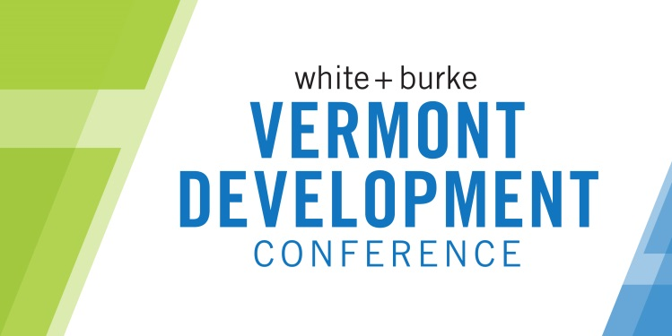

Vermont Development Conference
November 15, 2018
Topic & Speaker Suggestion
I would love to hear more about: ______________________________________________________________________
_________________________________________________________________________________________________.
An excellent regional/national keynote speaker would be: _________________________________________________
Other speakers I would be interested in hearing on local topics include: ________________________________________
__________________________________________________________________________________________________.

Session Proposal
We appreciate your interest in presenting one of the sessions at the 5th annual Vermont Development Conference. Please fill out the information below with details requested and forward by May 4 to vdc@whiteandburke.com. Please be aware that proposals submitted after this date may not be considered.
The VDC Committee will be refining the programming and will select and work with presenters leading up to the event to fully understand the content and develop the sessions. This may include tailoring your session proposal and will include speaker coaching and presentation requirements. Please keep in mind that these are intended to be valuable, content-packed time slots. These are not marketing sessions for presenters to a captive audience.

Name: | Title:
Organization: | Email:
Address: | Phone:

- Brief bio (please include professional credentials and other facts that relate to the presentation):

- Session format (check all that apply):
☐ Solo Speaker Presentation ☐ Panel Discussion ☐Other__________________
☐ Full Group Discussion ☐ Small Group Breakouts

- This session is best suited for:
☐ 45 minutes
☐ 75 minutes
Other________________

- Session Title:

- Brief description of your program session, including a description of audience participation/interaction (if any):

- Names, titles and affiliations of any other presenters participating in leading this session (if applicable):

- Who is your target audience for this session?

- At the end of the session, what will your participants know? What will be the three take-away points from your presentation?

- Please provide the contact information for at least one person that is familiar with your presentation style and content:
Sponsorship
Regionally/Nationally-recognized, significant keynote speakers are known to add value to a conference and would be a welcome addition to the VDC. But these people do not come cheap! If we could find such a coveted speaker, would your company be interested in being the Exclusive Keynote Sponsor for $5,000? *Would include all the benefits of the Platinum sponsorship and be exclusive! Yes □ No □
Please submit this form by May 4 to vdc@whiteandburke.com.

