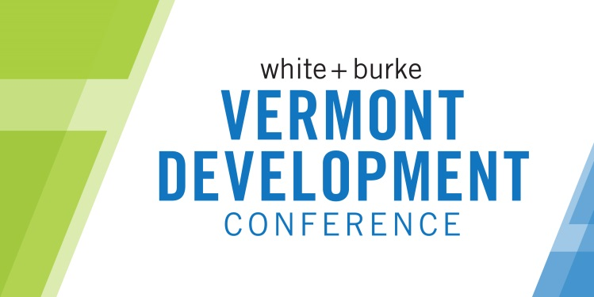

Vermont Development Conference
November 2, 2016
Hilton Burlington Hotel

We appreciate your interest in speaking in one of the sessions at the 3rd annual Vermont Development Conference. Please fill out the information below with details requested and forward by May 2 to vdc@whiteandburke.com. Please be aware that proposals submitted after this date may not be considered.
The VDC Committee will be making the selections of programming and will work with presenters leading up to the event to fully understand the content and develop the sessions. Please keep in mind that these are intended to be valuable, content-packed time slots. These are not marketing sessions for presenters to a captive audience.
Session Proposal
Name: | Title:
Organization: | Email:
Address: | Phone:

- Brief bio (please include professional credentials and other facts that relate to the presentation):

- Session format (check all that apply):
☐ Solo Speaker Presentation ☐ Panel Discussion ☐Other__________________
☐ Full Group Discussion ☐ Small Group Breakouts

- This session is best suited for:
☐ 45 minutes
☐ 90 minutes
Other________________

- Session Title:

- Brief description of your program session:

- Names, titles and affiliations of any other presenters participating in leading this session (if applicable):

- Who is your target audience for this session?

- At the end of the session, what will your participants know? What will be the main take-away from your presentation?

- Please provide the contact information for at least one person that is familiar with your presentation style and content:

Please submit this form by May 2 to vdc@whiteandburke.com.

